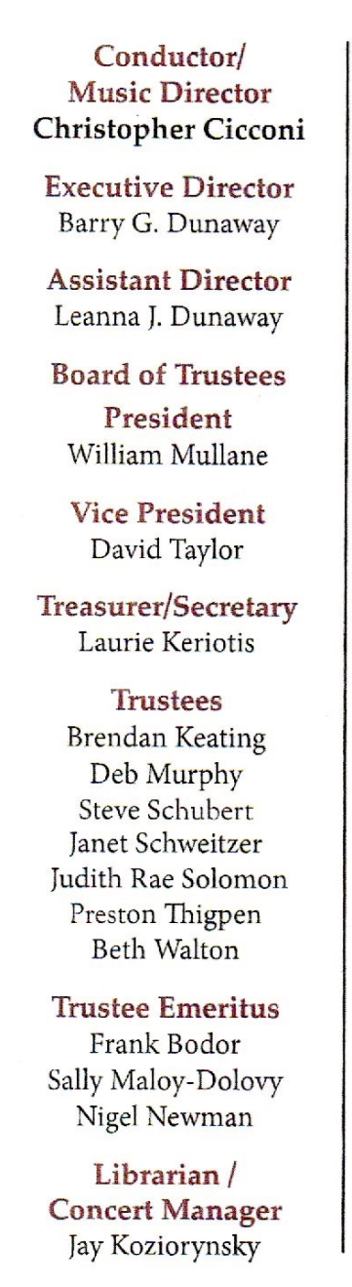
PRESS RELEASE FOR IMMEDIATE RELEASE
FOR MORE INFORMATION: Leanna Dunaway
Phone: 330-399-3606
Email: warren.philharmonic@gmail.com
Website: https://www.warren-philharmonic.org
Constant Contact for the Spring May 9, 2026 Concert

Sounds of Spring
Warren Philharmonic Orchestra Concert
Saturday, May 9, 2026 at 7:00 PM

The concert will be held at the Lakeview High School, 300 Hillman Dr., Cortland, OH 44410.

The Warren Philharmonic Orchestra Spring 2026 Concert will be held at the Lakeview High School, 300 Hillman Dr., Cortland, OH 44410. The concert date is Saturday, May 9, 2026, at 7:00 PM.

The Warren Philharmonic Orchestra will play the following:
Appalachian Spring (Ballet for Martha), Suite for 13 Instruments - Aaron Copland

Concerto in A Major for Piano and Orchestra No.23, KV 488 - Wolfgang Amadeus Mozart
I. Allegro
II. Adagio
III. Allegro assai

The soloist is Pianist Aleksandra Velgosha. Website: Aleksandra Velgosha - JMU

Pianist Aleksandra Velgosha was born in Moscow, Russia. She is a doctoral candidate at James Madison University and enjoys an artistic life of teaching, collaborating, and performing solo. Her recent community initiative included the launching of an annual New Piano Music Symposium in 2024, where JMU composers and pianists collaborate to present new piano works to the local community. Aleksandra's achievements include first and second
prizes in competitions like E. R. Davis Piano Competition, Crescendo Competition (Carnegie Hall, NY), and many others. Aleksandra has appeared in solo and collaborative performances throughout the United States and Europe and has performed at such festivals as Port City Music Festival, American Liszt Society Festival, and Staunton Music Festival. She appeared as soloist with such ensembles as Tula Regional Orchestra (Tula, Russia), New England Youth Ensemble (Takoma Park, MD), JMU Wind Symphony and JMU Brass Band (Harrisonburg, VA). Aleksandra received her BM in Piano Performance with honors from Washington Adventist University with Dr. Mark Di Pinto and completed her master's degree at the University of Maryland under Prof. Larissa Dedova. Aleksandra studies at JMU with Dr. Gabriel Dobner and has taught at such institutions as University of Maryland, Christopher Newport University, Richardson School of Music, Takoma Academy, and Chanson Music School. She currently serves as an adjunct faculty at James Madison University.

INTERMISSION

Symphony No. 6 in F Major ‘Pastorale’, Op. 68 - Ludwig van Beethoven
I. Allegro ma non troppo
II. Andante molto mosso
III. Allegro
IV. Allegro - Thunder Storm
V. Allegretto

INTERMISSION
Symphony No. 5 in D Minor - Dimitri Shostakovich
IV. Allegro non troppo
Side by side performance with the Youngstown State University Youth Orchestra

The Warren Philharmonic’s professional musicians have won raves for their superb performances, stellar musicianship and captivating programs of compositions from the 1700s to pieces just composed. The May 2026 Spring concert ends the Orchestra’s 60th performance season.

Tickets for the Saturday concert may be purchased at the door: adults $30.00, students $15.00. Children under the age of thirteen are admitted free, with a parent or guardian. Phone the Warren Philharmonic Orchestra office at 330-399-3606 or send email to warren.philharmonic@gmail.com for more information. Facebook: Warren Philharmonic Orchestra. Website: http://www.warren-philharmonic.org/

