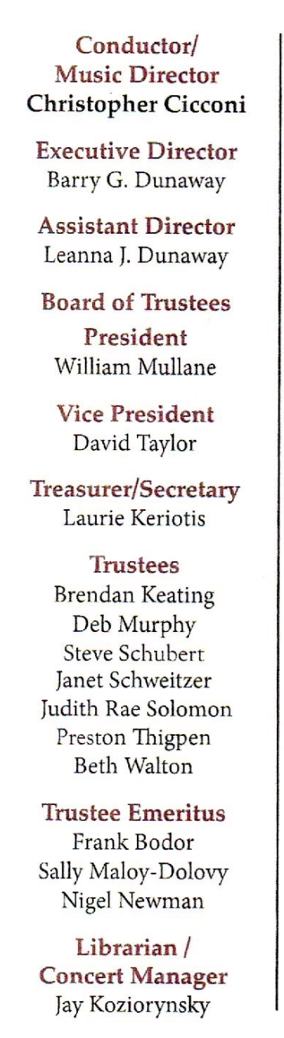
PRESS RELEASE
FOR IMMEDIATE USE FOR MORE INFORMATION
Leanna Dunaway
Phone: 330-399-3606
Email: warren.philharmonic@gmail.com
Website: https://www.warren-philharmonic.org

Fall Masterworks
Warren Philharmonic Orchestra Concert
Saturday, October 4th, 2025, at 7:00 PM

The concert will be held at the Lakeview High School, 300 Hillman Dr., Cortland, OH 44410.

The Warren Philharmonic Orchestra Fall 2025 Concert will be held at the Lakeview High School, 300 Hillman Dr., Cortland, OH 44410. The concert date is Saturday, October 4th, 2025, at 7:00 PM.

The Warren Philharmonic Orchestra will play the following:
- Overture to Egmont, 0p. 84 - Ludwig van Beethoven (1770 - 1827)
- Seigfried-Idyll, WWV 103 - Richard Wagner (1813 - 1883)
- Habanera - Emmanuel Chabrier (1841 - 1894)

~Intermission~

Symphony No. 4, Op. 90 ‘Italian’ - Felix Mendelssohn (1809 - 1847)
I. Allegro vivace
II. Andante con moto
III. Con moto moderato
IV. Salterello. Presto

The concert begins with Beethoven, Dr. Christopher M. Cicconi, Conductor and Music Director of the Warren Philharmonic Orchestra states in the program notes: Beethoven was commissioned to write incidental music for Wolfgang von Goethe’s interpretation of Count Egmont’s 16th-century struggle for Dutch independence against the autocratic imperial rule of Spain.

Richard Wagner's Siegfried Idyll was an intimate musical gift to his wife, Cosima, for her 33rd birthday and the first Christmas after their son Siegfried's birth.

The French composer Emmanuel Chabrier wrote a very beautiful, work for piano called Habanera. Later he reworked the music and orchestrated it in 1888, producing a lovely miniature for orchestra.

Mendelssohn went to Italy in October 1830. His impressions of the trip resulted in the present Symphony. The work strives more to convey a series of impressions of Italy—Mediterranean sunshine, religious solemnity, monumental art and architecture, and open countryside.

The full program notes are available on the Warren Philharmonic Orchestra website.

The Warren Philharmonic’s professional musicians have won raves for their superb performances, stellar musicianship and captivating programs of compositions from the 1700s to pieces just composed. The October 2025 Fall concert begins the Orchestra’s 60th performance season.

Tickets for the Saturday, October 4th, 2025, concert can be purchased at the door: adults $30.00, students $15.00. Children under the age of 13 are admitted free, with a parent or guardian. Phone the Warren Philharmonic Orchestra office at 330-399-3606 or send email to warren.philharmonic@gmail.com for more information. Facebook: Warren Philharmonic Orchestra. Website: http://www.warren-philharmonic.org/

